

**Team #59**

**Final Project Report**

**Team members:**

**Sarvar Khursandov U1810131 (Team leader)**

**Makhmudbek Rasulov U1810193**

**Javokhir Rasulov U1810061**

**Qudrat Nosirov U1810073**

**Asrorjon Pirmukhamedov U1810090**

**Introduction**

This assignment report contains information about the process of completing final project in which we were supposed to implement a code for given Raspberry Pi Cart.

Our main goal of this final project is to achieve stable process of completing various missions on a competition track under the road conditions similar to real-world roads.

**Team member roles:**

|  |  |  |  |
| --- | --- | --- | --- |
| **Team Mission Statement** | | | |
| **Team #** | **59** | **Leader** | **Sarvar Khursandov** |
| **Name** | | **Main Responsibility** | |
| Khursandov Sarvar and Javokhir Rasulov | | Both of them have strong knowledge of software development. They were responsible for code optimizations and creating new functions. | |
| Makhmudbek Rasulov | | Contributed in hardware related aspects and problems. Responsible for performance tests. | |
| Nosirov Qudrat | | Responsible for meetings. Distributed tasks. Was responsible for report and research. | |
| Pirmukhamedov Asrorjon | | Tested code and hardware. Researched data from resources and helped with problem solving. Helped with report. | |

**Team minutes:**

|  |  |  |  |  |  |  |
| --- | --- | --- | --- | --- | --- | --- |
| **Team Minutes** | | | | | | |
| **Team #** | **59** | **Leader** | **Sarvar Khursandov** | | | |
| **Main goal** | The main purpose of the team is to complete tasks of the final project with fulfilling all requirements. | | | | | |
| **Purpose of the meeting** | Familiarization with the project, scheduling meetings | Starting coding process and researches | Completing  Lane detection | Completing  Object detection | Testing day!  Solving emerged problems. | Final tests and wrapping everything up |
| **Meeting time** | 30.04.22  15:00 – 18:30 | 02.05.22  16:00 –18:30 | 04.05.22  15:00 – 19:00 | 06.05.22  16:30 – 20:00 | 07.05.22  15:30 – 18:30 | 08.05.22  16:30 – 20:00 |
| **Participation** | **ALL** | **ALL** | **ALL** | **ALL** | **ALL** | **ALL** |

**Main Goal:**

What we should do in this project is to insert our code to the Raspberry Pi Cart and using camera and different types of methodologies (such as lane detection and object detection) arrive to the finishing point of the road. During this process we also should satisfy evaluation criteria like traffic signal recognition, traffic sign recognition, auto parking, and avoidance of obstacles on the racing map.

**Map of the road:**

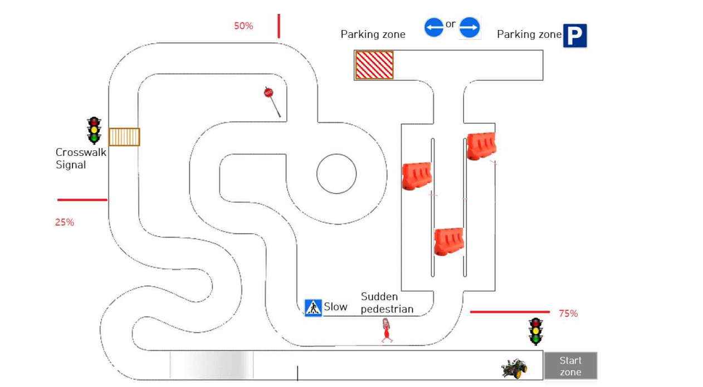

**Lane detection methodology:**

We used Canny edge methodology, Canny Edge detector needs grey scale images, hence we need to convert our image into grey scale. We are collapsing 3 channels of pixel value (Red, Green, and Blue) into a single channel with a pixel value range of [0,255]. Lane lines are always yellow and white. Yellow can be a tricky color to isolate in RGB space, so we converted instead to HSV color space.

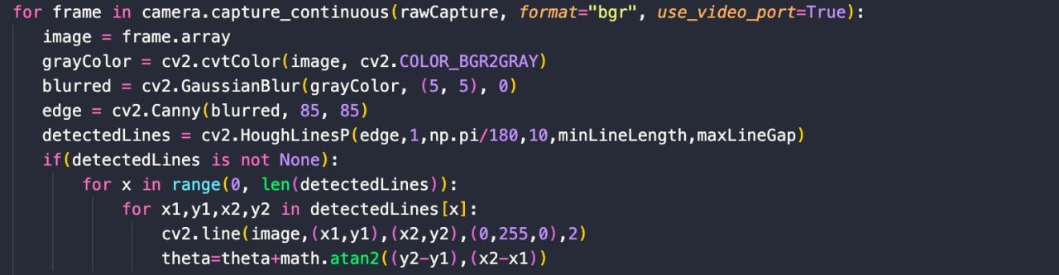

**Object detection methodology:**

In this project we did not use any object detection methodology, if we have time to use it, we would use Haar cascade. Haar cascade classifiers are considered as the effective way to do object detection with the OpenCV library.

**Detailed information regarding open-source code:**

We took some codes from lectures, for example finding the angle of lines, detecting lines by color. Actually we separate codes to two part, first part responsible for detecting lines, second part is main functions of machine movement like, init motor, stop motor, moving forward, left, right.

**Images from testing runs:**

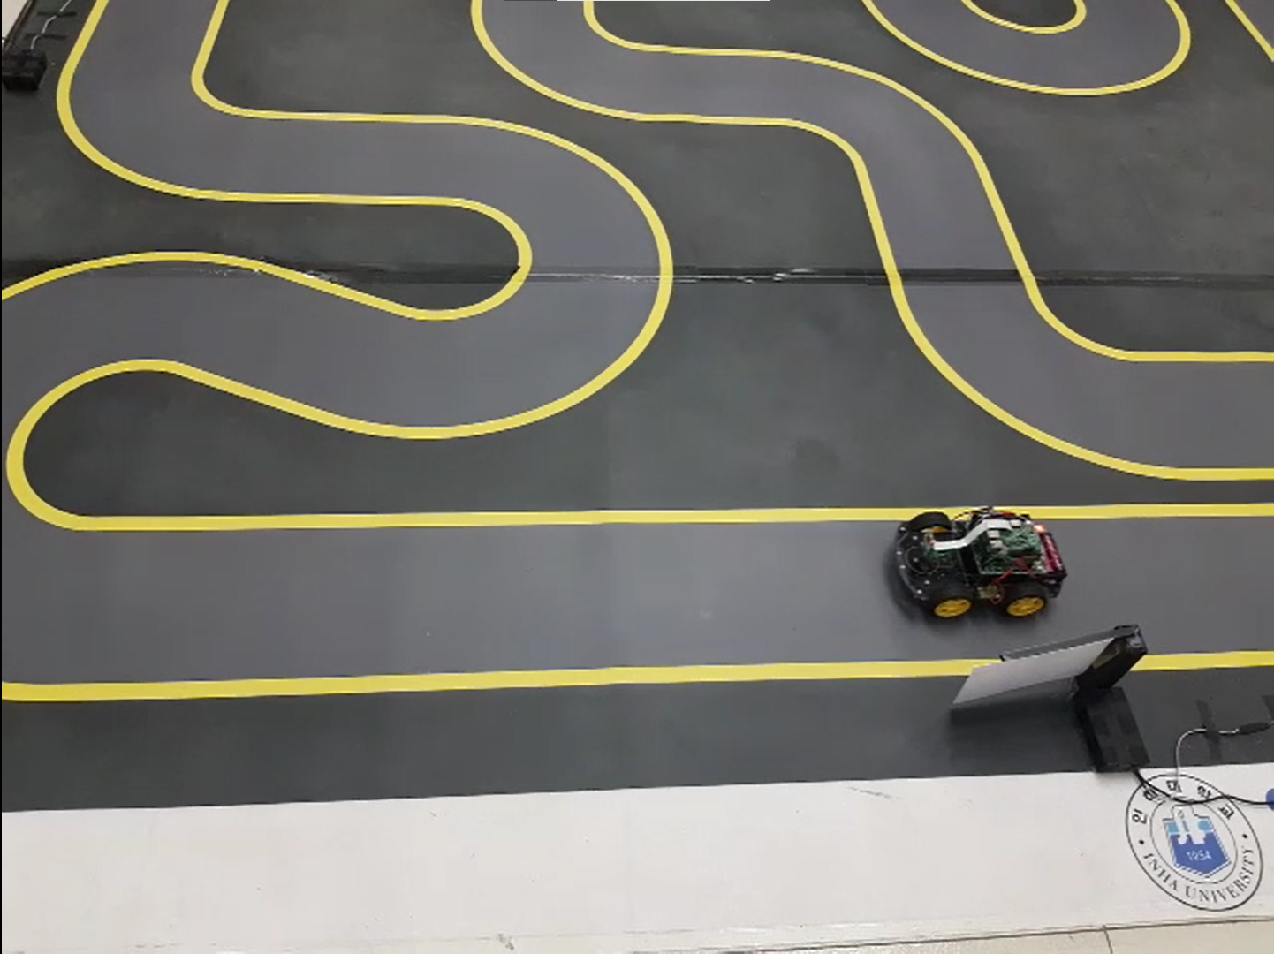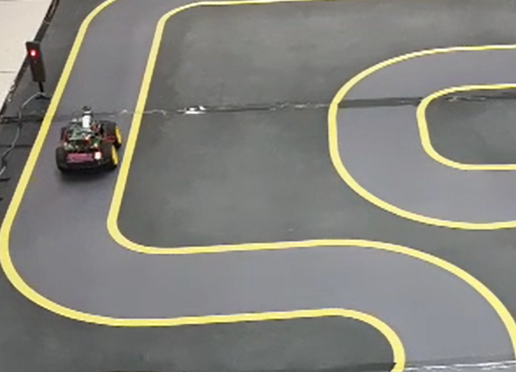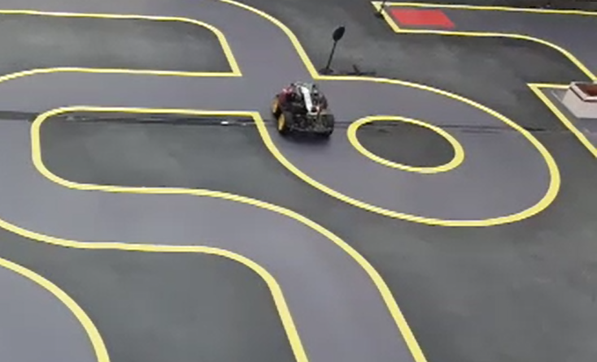

**Team Rules:**

**Rule 1: Open mindedness**

The work process is determined by every team member suggestions of good decisions during the process of work and not by one member.

**Rule 2: Exchange policy**

Every team member is obliged with a task, however If someone is in difficulty during certain stage, other team member should help and they should exchange roles for a period of time

**Rule 3: Effectiveness**

If there are multiple drawbacks and errors during the test and if nothing goes on, the work must be put to pause and moved to analyzation session with members all together that longs 20 minutes

**Rule 5: Organization**

Every work or assignment should be organized and put through in details before it is started. Ignoring small details results in additional errors and time loss.